# Problem 4 – Robbery

You are robber who just stole a TV. Now you must escape the cops without being caught. You are given a map of the city streets. However, the TV is quite heavy and you have **limited energy E**. There a few rules:

* Going from one point to another costs you some **energy** (displayed as a value on each arrow) and takes one turn.
* Each point is being watched by a **video camera**. A point can be **black** (a camera is **not** watching it) or **white** (a camera is watching it). Every turn points change color to the opposite (from black to white and vice versa). See the example below.
* You can only travel to points where the **camera is currently on** (because when you step on it the camera will be off and you will not be caught).
  + After stepping on a point you can **wait 0 or more turns** before going further (the camera will not catch you). Note that every turn you wait costs **W energy**.

Find the path that requires the **least energy** to go to the final point. Print the required energy.

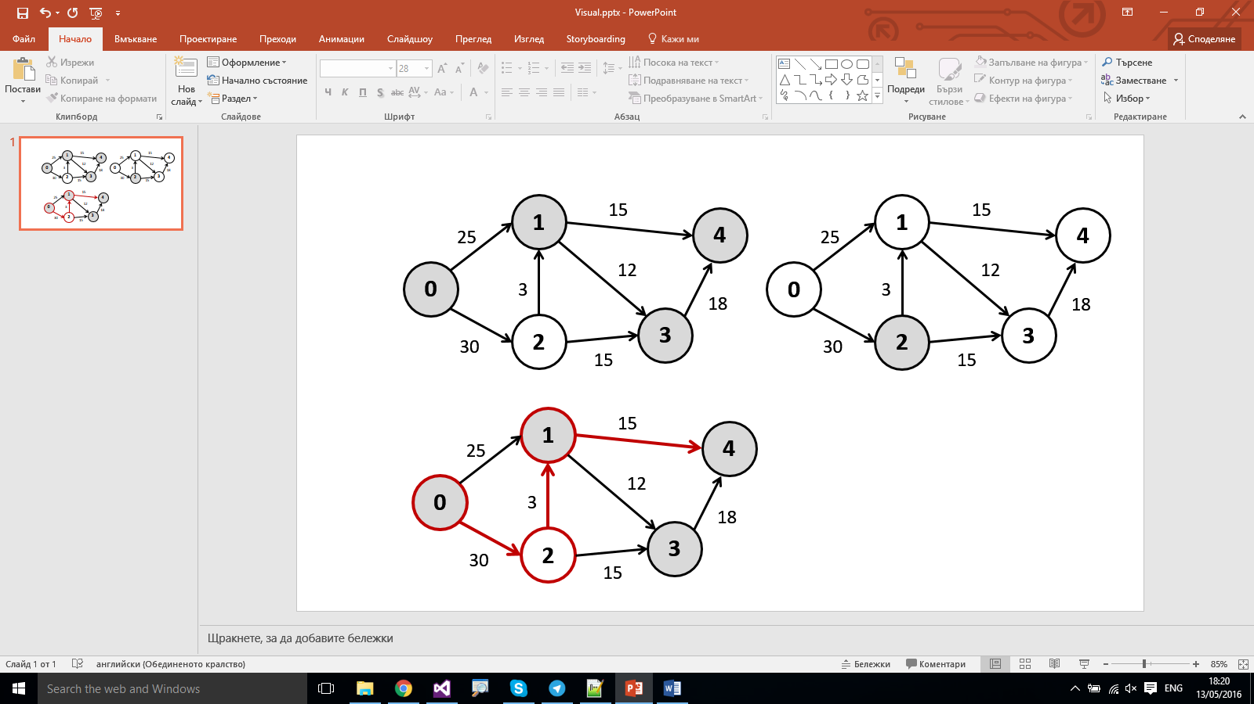

*At each turn points change color as shown above*

### Input

* On the first line you will receive all points in the format "**<node1><color1> <node2><color2> …<nodeK><colorK>**".
* On the second line, you will receive the **starting energy**.
* On the third line, you will receive the cost (in energy) for **waiting one turn**.
* On the fourth line, you will receive the **starting node**.
* On the fifth line, you will receive the **ending node**.
* On the sixth line you will receive a number - **n** specifying the **number of point connections**.
* On the next **n** lines you will receive the connections in the format "**<start> <end> <distance>**"

### Output

* Print the **amount of energy you have** at the end.
* If you do not have enough energy, print how much energy you still need to reach the end in the format "**Busted - need *{x}* more energy**".

### Constraints

* The amount of points in the city will be between **[2…20000]**.
* The starting energy **E** will be a valid integer between **[0…100000].**
* The waiting cost **W** will be a valid integer between **[0…10000].**
* The distance of a connection will be a valid integer between **[0…10000].**
* The points will always be numbers starting from **0**.
* The color will be either "**b**" or "**w**" – **b** means the camera is currently **not** watching, **w** means the camera is currently watching.
* There will always be a valid path from **start** to **end**.
* Time limit: **100 ms**. Allowed memory: **32 MB**.

### Examples

|  |  |  |
| --- | --- | --- |
| **Input** | **Output** | **Visual** |
| 0b 1b 2w 3b 4b  70  10  0  4  7  0 1 25  0 2 30  1 3 12  1 4 15  2 1 3  2 3 15  3 4 18 | 12 |  |
| **Comments** |
| Start from 0.   * Going to 2 costs 30 energy. * Going to 1 costs 10 (for waiting one turn) + 25 = 35 energy   From 2 we go directly to 1 with energy 3.  From 1 we need to wait 1 turn for both 3 and 4 to become white and then go for 4 (10 + 15 = 25 energy). |

|  |  |
| --- | --- |
| **Input** | **Output** |
| 0b 1w 2w 3w 4w 5b 6b 7w 8b 9w 10b 11b 12w 13w  99  5  1  11  18  1 0 5  1 2 17  1 3 22  3 4 17  3 5 4  5 6 3  5 7 12  6 4 7  6 8 31  7 2 5  7 10 117  8 9 44  9 10 2  10 6 9  10 12 29  11 9 1  12 13 16  13 11 8 | Busted - need 75 more energy |
| **Comments** |
| *(Path is* ***1 -> 3 -> 5 -> 6 -> 8 -> 9 -> 10 -> 12 -> 13 -> 11****)* |